CST8218 Group **#6** Assignment

SOSTutors  
Status Report 1 (v0.1)

**Group Members:** Aboubacar Konde (040770799)  
 Harry Hidayat (040375590)  
 Jordan Gignac (040768816)  
 Muzammil Mirza (040746051)  
 Safi Naseem (040731978)

**Professor:** Douglas King  
 **Date:** 04 February 2016

# Introduction:

A *student* sometimes need help in the pursuit of knowledge. Sometimes the help provided by their school is not enough. One way of getting extra help is to hire a private tutor. A *tutor* is someone who is knowledgeable who can help students understand the more difficult ideas around a particular subject.

# Project plan

For our initial submission we had the following goals:

## 0.1

• Designing the website look and feel with CSS and HTML (Muz, and Safi).

• Initial database design (Harry).

• Creation of non-interactive pages using HTML (Jordan and Aboubacar).

For 0.1 everything went according to plan. We aimed low because from the onset we had problems with GitHub such as some of our members unable to Push and/or properly.  
  
We also encountered communications problems where some work were overwritten but the work was mostly salvageable.   
  
Given these problems and the team’s experience working in a version control environment the start was not without bumps. As we get better developing using git, for our next release we will aim higher.

# Architecture

## Data Aspect

The server files (including database) will be stored on a machine(server) running Apache Tomcat.

User data such as user credentials and passwords will be stored in a MySQL database. The database structure will initially have this structure. The design has not been tested or implemented and might change over development.

MySQL  
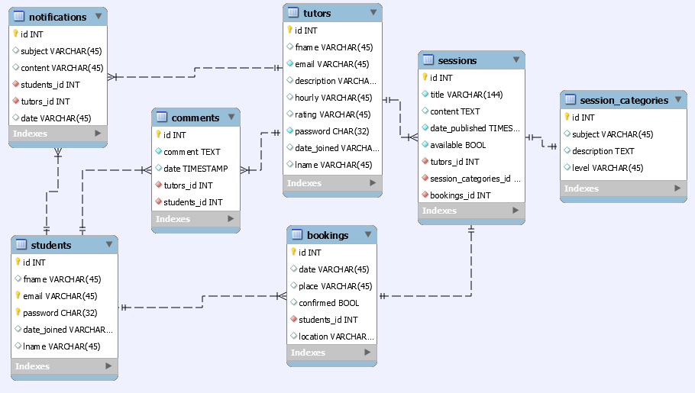  
/Documents/Database/SOSTutor.sql – Harry Hidayat  
Database connection is not yet implemented in this release.

## Look And Feel

The web site will use CSS to change its look and feel, such as flat buttons, flat table borders, etc. The website will be rendered within the browser using HTML and Javascript.   
  
  
CSS  
styles/styles.css – Jordan Gignac   
  
JSP MAIN PAGES  
Contact.jsp - Aboubacar Konde  
About.jsp - Muzammil Mirza  
Tutor.jsp - Safi Naseem  
TutorSearch.jsp – Jordan Gignac  
Index.jsp - Harry Hidayat  
  
JSP ERROR PAGES  
Exception.jsp - Aboubacar Konde  
404.jsp – Jordan Gignac  
408.jsp - Harry Hidayat  
500.jsp - Safi Naseem  
502.jsp - Muzammil Mirza  
504.jsp - Aboubacar Konde  
  
NEXT Release

## 0.2 (THE FOLLOWING MIGHT CHANGE DURING DEVELOPMENT)

* Fixes for any bugs that came up during initial conception. (Jordan Gignac).
* Improve Database (Aboubacar Konde).
* Implement Database (Harry Hidayat).
* Design the Calendar (Muzammil Mirza).
* Start to develop the Calendar (Safi Naseem).
* Add Registration logic. (Muzammil Mirza).
* Add Login logic (Harry Hidayat).
* Add Search Tutors logic (Aboubacar Konde).
* Begin implementation of the booking system Safi Naseem).